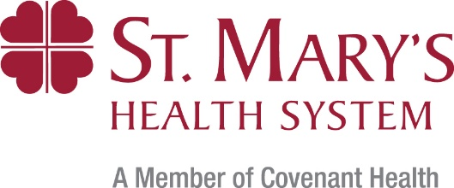

Leave a Legacy Gift to St. Mary’s Health System

Please let us know that you have provided a planned gift for St. Mary’s Health System in your will, trust, pooled life income fund, life insurance policy, gift annuity, or retirement fund. When you do, you immediately become a member of the St. Mary’s Legacy Society. Members are listed in the Annual Report and are honored at appropriate special events. Members are eligible for naming opportunities (at levels in accordance with your planned gift value) and donor wall recognition. We invite you to share your ideas for how to recognize and celebrate your legacy giving to St. Mary’s Health System.

Please submit this statement of intent to join the St. Mary’s Legacy Society.

Name Click or tap here to enter text.
Spouse/Partner Name Click or tap here to enter text.
Address Click or tap here to enter text.
City Click or tap here to enter text. State Click or tap here to enter text. Zip Click or tap here to enter text.
Phone Click or tap here to enter text. Email Click or tap here to enter text.

☐ Yes, I have made a provision in my estate planning to benefit St. Mary’s Health System.

The provision is in the form of a:
☐ Bequest ☐ Retirement Fund Beneficiary Designation
☐ Charitable Gift Annuity ☐ Life Insurance
☐ Other:

I would like my gift used for the following purpose: Click or tap here to enter text.

St. Mary’s Legacy Society Gift Recognition:
☐ List the name(s) above in all publications. ☐ I/we prefer to remain anonymous.

Estimated Value of Gift: $Click or tap here to enter text.

A copy of the relevant portion of the legal document in which your gift is described would be helpful but is not required.

Click or tap here to enter text. Click or tap to enter a date.
Name Date

Click or tap here to enter text.
Signature

Please return this form to Deb Anthoine, Executive Director of Philanthropy, St. Mary’s Health System
PO Box 7291, Lewiston, ME 04243 • Email: danthoine@stmarysmaine.com • Phone: 207.777.8828

